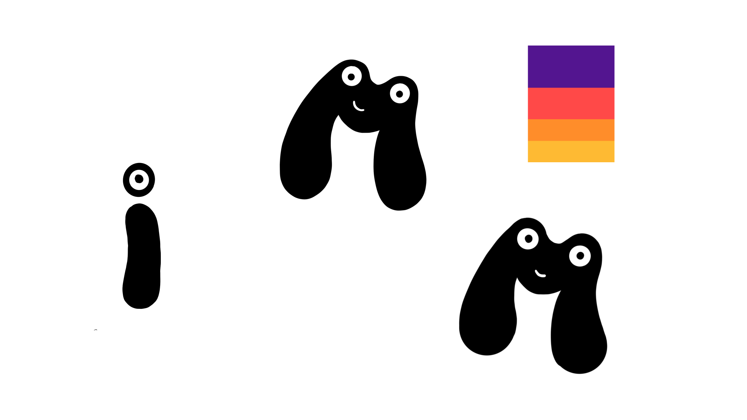**[FREE GUIDE] Shoot EPIC MOVIES with this FREE AI Tool!**

**This is the free installation guide for:** [**https://youtu.be/gHI6PjTkBF4?si=8walRtllFCc_FmEr**](https://youtu.be/gHI6PjTkBF4?si=8walRtllFCc_FmEr)

**1 Install ComfyUI**

1. Download ComfyUI: <https://github.com/comfyanonymous/ComfyUI/releases/tag/v0.2.3> (zip)
2. Extract the folder to the location where you want to install ComfyUI.
3. install git <https://git-scm.com/download/win>

* standalone version

1. Download ComfyUI Manager: <https://github.com/ltdrdata/ComfyUI-Manager>
2. Extract it, put it into your ComfyUI directory and run it.
3. After it’s done you can run ComfyUI by clicking **run_nvidia_gpu**

Congratulations, you installed ComfyUI! 🥳 To use my workflows you’ll need some extra models and extensions, but it is super easy to install them!

**2 Install Missing custom Nodes**

1. Start ComfyUI by clicking **run_nvidia_gpu**
2. ComfyUI will now start in your browser
3. Drag my workflow(s) .json files into the interface
4. Go to Manager > Install Missing Custom Nodes > select all of them > Install

**3 Download Models**

1. Get the **Clip Model** here:

* Go into the ComfyUI Model Manager
* search for "t5"
* install "t5-v1_1-xxl_encoderonly-fp8_e4m3fn"
* click "r" to refresh, select it in the "Load Clip” Node.

1. Get the Reward Lora here:

* <https://huggingface.co/alibaba-pai/CogVideoX-Fun-V1.1-Reward-LoRAs/tree/main>
* Download: **CogVideoX-Fun-V1.1-5b-InP-MPS.safetensors**
* Place in: ComfyUI\models\CogVideo\loras
* refresh and select

1. Upscale Model:

* I am using <https://openmodeldb.info/models/4x-ClearRealityV1>
* Download and put into ComfyUI\models\upscale_models
* You can also use "**4x-UltraSharp**". You can install that one via the model manager.

**4 For the advanced workflows:**

**Install additional models:**

1. **Checkpoint:**

* I am using photon_v1. But any SD 1.5 Model will work.
* Download the model: https://civitai.com/models/84728/photon
* Place in: **ComfyUI\models\checkpoints**

1. Controlnet:

* Go into the model manager, search "openpose" and install:

**ControlNet-v1-1 (openpose; fp16)**

1. **Motion Model:**

* Go into the model manager, search "mm" and install: **animatediff/v3_sd15_mm.ckpt (ComfyUI-AnimateDiff-Evolved) (Updated path)**
* refresh, select it in the “AnimateDiffLoader” node

**Install Reactor Face**

1. Install the Reactor Face nodes via the ComfyUI Manager.
2. Find out which Python version you are using by running “python” in ComfyUI_windows_portable\python_embeded
3. Download the corresponding insightface version here: <https://github.com/Gourieff/Assets/tree/main/Insightface>
4. Right click on that file > “Copy as path”
5. Go back to your comfyUI, type in “cmd” in the address bar > open terminal and run this command:
6. **.\python_embeded\python.exe -m pip install "paste path here" onnxruntime**

in my case it looked like this:

.\python_embeded\python.exe -m pip install "C:\Users\mick\Downloads\insightface-0.7.3-cp311-cp311-win_amd64.whl" onnxruntime

1. Once it is installed run

**python.exe -m pip install numpy==1.26.4**

1. Restart ComfyUI